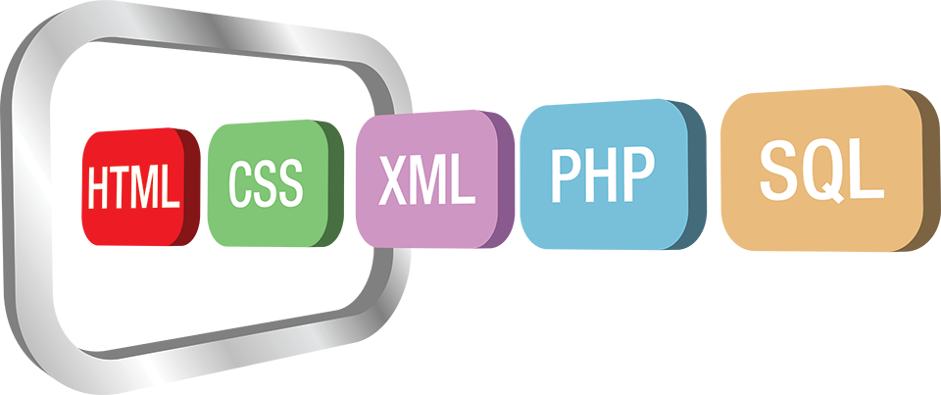

**The Problem**

IT skills are in demand as more jobs require IT as part of the daily tasks. This has increased the value of IT skills, but also has led to less skilled IT workers. Bootcamps and other programs have rushed through teaching skills without the ability to apply them. Thus, we have a glut of low skilled IT workers and not enough higher-level mentors and leaders.

**The Solution**

We are taking a combination of decades of experience across numerous lines of business to find problems that IT can solve. We use these as focus points for teaching developers rather than simple coders. Our goal is to teach students how to learn and advance through real world problem solving. Every course and class have concrete goals and deliverables. These provide students with more than a certificate of completion when they are done. They have skills and a plan to use them.

**Start Today!**

We realize that time and money are at a premium. We eliminate those as barriers to launching a business or improving skills. Our first course starts with entry level skills centered around building a blog site. It includes higher end topics like building a business, generating revenue from a variety of web sites using social networking sites. When students complete this course, they will be well positioned to launch a side hustle and earn some extra cash. We then offer focused mentoring and mastermind groups and regular content to help grow a business. This first course covers:

* **Linux Basics**
* **Web Server Administration**
* **Database basics (MySQL)**
* **Cloud Development Basics - Amazon’s AWS**
* **Affiliate Marketing**
* **Blogs and Marketing web sites**
* **Creating your business**
* **Professional Communication**
* **Your Personal Brand**
* **Advertising/Monetizing your site**
* **Site Analytics**

Better Developers Through Application, not Theory

# What is Develpreneur.com?

Introductory Course

Launching an Internet Business - Web Development

Our first course focuses on setting up a web server and web development. We include Wordpress and Linux basics. This course also includes steps to create and launch a business. Thus, our students can start converting these new skills into better pay immediately.

Free And Easy

The class is delivered in bite-sized chunks each day including a 15 minute how-to video for each lesson and additional material as needed. The free course takes the student through launch using free tools and platforms with only the domain name being a start-up cost.

Questions?

Contact us at [info@develpreneur.com](mailto:info@develpreneur.com) or check out our site at https://develpreneur.com

[develpreneur.com](http://develpreneur.com) | Email : info@develpreneur.com